Report

project description:
Destinations is a travel agency located in Colorado. Destinations has several affiliate companies that focus on specialized travel packages. You are a travel consultant for Destinations. Each month, you research a country and write a report about it. These reports are sent to clients who have expressed interest in visiting that country. The reports are also used in Destinations monthly newsletter, when that country is featured. The upcoming feature country is Japan.
additional information and instructions:
- In this project, you will format and prepare a report on Japan using internal citations, a cover page, enhanced footers, and a bibliography.
- A report communicates information about a topic. The topic may be formal or informal. The report is usually mostly a text-based document. Most reports require research and some include the writer’s opinion or position on the topic.
- The margins for a report depend on how the report is bound: Unbound – 1” left and right, 2” top, 1” bottom; Left-bound – 1.5” left, 1” right, 2” top, 1” bottom; Top-bound – 1” left and right, 2.5” top, 1” bottom.
- The line spacing of a report is typically double.
- Open the japancities file saved on the Hshare. The file contains the text required for the report.
- Save the file in your own directory.
- An example of the completed report is shown at the end of this document.
- Apply the following settings:
  - Set margins for a left-bound report
  - Set the line spacing to double
  - Century Gothic, size 12 font
- Continue to enhance the look of the report by doing the following:
  - Set the font of the title to 14 pt, bold, dark red
  - Use the format painter to apply this same formatting to the city names (NARA, OSAKA, etc.)
  - Set the font for the first city location (Southern Honshu) to Calibri, 10 pt, blue
  - Use the format painter to apply this same formatting to the remaining city locations
  - Insert an appropriate symbol before the first city
  - Copy and paste the same symbol so that it appears before each city name
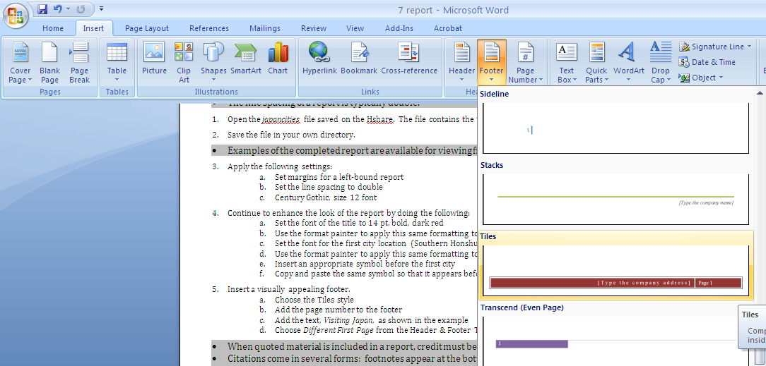
- Insert a visually appealing footer.
  - Choose the Tiles style
  - Add the page number to the footer
  - Add the text, Visiting Japan, as shown in the example
  - Choose Different First Page from the Header & Footer Tools Design tab

- When quoted material is included in a report, credit must be given to the source by using citations.
- Citations come in several forms: footnotes appear at the bottom of the page, endnotes appear at the end of the report, internal citations appear within the report’s text.
- Word’s Citation feature allows you to enter source information, which Word formats properly and inserts at the location you specify.
- Add MLA style internal citations (shown in the example) by doing the following:
end of 1st paragraph
  - Click the Reference tab
  - Click the Style tool, from the Citations & Bibliography group of tools, and select MLA as the style
  - Click the Insert Citation option and select Add New Source
  - Use the information below to fill in the Create Source dialog box:
Type of Source: | Book
Author: | Alex Kerr
Title: | Lost Japan
Year: | 2005
Country/Region: | Australia
Publisher: | Lonely Planet

middle of 3rd paragraph
- Repeat Steps a through c above
- Use the information below to fill in the Create Source dialog box:
Type of Source: | Book
Author: | Brian Bell
Title: | Insight Guides: Japan
Year: | 2008
Country/Region: | Boston
Publisher: | APA Publications

middle of 5th paragraph
- Repeat Steps a through c above
- Use the information below to fill in the Create Source dialog box:
Type of Source: | Book
Author: | Joanna Grey
Title: | The Wonders of Japan
Year: | 2009
Country/Region: | Chicago
Publisher: | TTX Publications

- Regardless of the type of citation, a complete list of sources also needs to be included.
- Create the list of sources by doing the following:
  - At the bottom of the last page, insert a page break to begin the source list on a new page
  - On the References tab, click the Style tool, from the Citations & Bibliography group of tools, and select MLA as the style
  - Click the Bibliography tool and select Works Cited
  - The source information (previously entered when adding internal citations) should automatically be formatted and added to the page

- Word provides a gallery of predesigned cover pages. Regardless of where your cursor is, Word places the cover page at the beginning of the document.
- Create a visually appealing cover page by doing the following (illustrated to the right):
  - Choose the Tiles style Note: Some text or other information may be added automatically by Word 2010. Edit and/or delete information as needed to fit this report.
  - Delete the placeholders for Company, Year, Company Address, and Subtitle
  - Type your name in the Author placeholder
- Spell check, proofread, and save the document.
- E-mail a copy as an attachment. Be sure to put an appropriate description in the subject line of the e-mail. If e-mail is not available, print in color.

