Report with Table of Contents

information and instructions:
- In this project, you will format and prepare a report on globalization. The report has footnotes and a table of contents will be added to make it easier to find information within the report.
- Remember, a report communicates information about a topic.
- Remember, the margins for a report depend on how the report is bound: Unbound – 1” left and right, 2” top, 1” bottom; Left-bound – 1.5” left, 1” right, 2” top, 1” bottom; Top-bound – 1” left and right, 2.5” top, 1” bottom.
- The line spacing of a report is typically double.
- Open the globalization file saved on the website. The file contains the text required for the report.
- Save the file in your own directory.
- Apply the following settings:
  - Set margins for an unbound report
  - Set the line spacing to exactly 20 pt.
  - Use Century Gothic, size 12 font
- Correct errors in keying, spelling, grammar, etc. as shown with proofreader’s marks on the pages attached.
- A footnote is a note of text placed at the bottom of a page in a document. The note can provide an author's comments on the main text or citations of a reference in support of the text, or both.
- There is a Footnotes feature available in Word 2010 that makes the process of creating footnotes effortless.
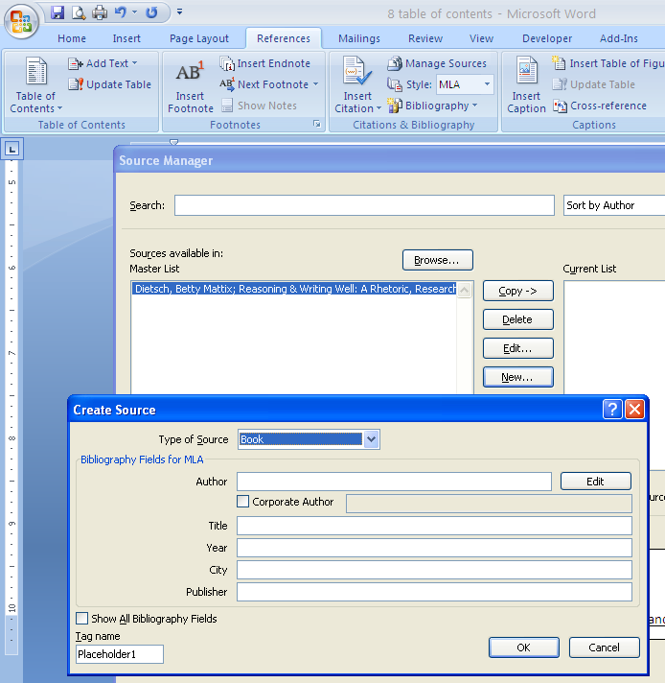
- From the References tab, choose Insert Footnote. A sequential number is placed in the document (at the exact location of the cursor). Then, the cursor is automatically popped down to the footer area where the citation information can be keyed. The visual example will help.
- Add footnotes to the report as shown on the attached pages. For example, footnote #1 is placed after the last word in the first paragraph. Note: Your text may not be on the exact same page as shown in the example.
- Add the source information, listed in each footnote, as new sources in the Manage Sources tool. From the Manage Sources dialogue box, click New.. and fill in the Create Source information.
- Regardless of the type of citation, a complete list of sources also needs to be included.
- Create a Bibliography page as described in the previous exercise.
Before going any farther, watch a few short videos about the table of contents feature that is new to Microsoft Office Word 2010.
- Ensure the Table of Contents will be set up properly by doing the following:
  - Set the text GLOBALIZATION, on the first line of the report, to the “Title” style
  - Set the headings Causes of Globalization, Trade Agreements, and Summary to the “Heading 1” style
  - Set the subheadings GATT, The European Community, and NAFTA to the “Heading 2” style
- Create an Automatic Table of Contents as described in the videos.
- Spell check, proofread, and save the document.
- Add your name to the header area and e-mail.

